Seton Medical Center Harker Heights
ACCU-CHEK Inform II Meter Post Test

Student / Associate Name: __________________________________
School / Unit: ___________________ Date: ___________________

Directions: Mark the correct answer and return the completed test to your faculty. A minimum score of 80% is required for Blood Glucose Monitoring privileges as well as completion of competency form.

TRUE OR FALSE

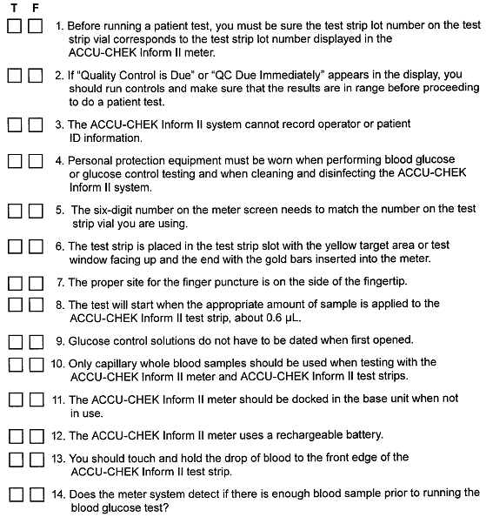

Fill in the blanks.

